TASK 1:

A.

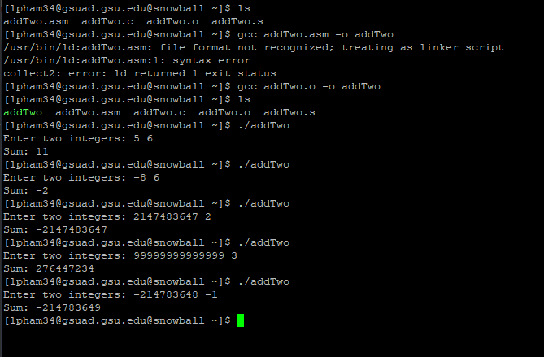

C.

Case “c”, 2147483647 is the maximum value for a singed 32-bit integer. Adding any number will result in a negative number due to overflow

Case “d”, number 99999999999999 exceeds the 32-bit integer range.

Case “e”, -2147483648 is the minimum value for a signed 32-bit integer. Subtracting 1 will results in an underflow.

D.

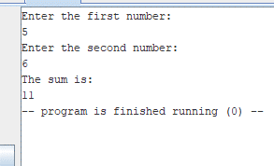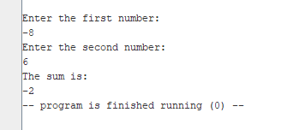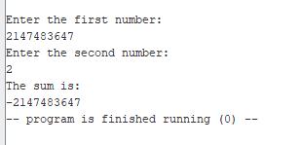

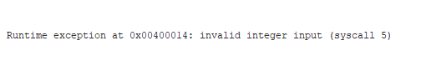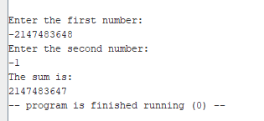

TASK 2: